UniStyle E-Commerce Test Plan
Test Plan ID | TP-UNISTYLE-01
Version | v1.0
Date | 2025-10-19
Project Name | UniStyle, E-Commerce Web App
Test Manager | Garam Yoon
Test Objectives | This test plan focuses on early defect detection and acceptance criteria validation for prioritized user stories.
Test Scope | 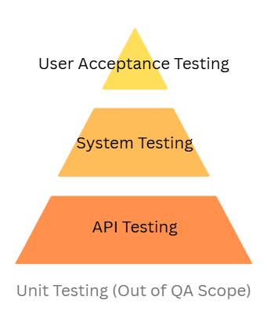  API Testing  - Authentication & JWT  - Product CRUD  - Cart & order services  - Payment integrations  System Testing  - Core user-facing features  - Role-based access via UI  - Form validation & navigation  User Acceptance Testing  - End-to-end user scenarios  - Usability & UX validation  - Business acceptance criteria  Unit Testing  Figure 1: Test Scope Pyramid  - Out of QA scope (handled by development)
Test Strategy
  Testing Approach | Purpose
  Black-box | Validate system behavior via inputs/outputs
  Requirement-based | Validate prioritized requirements and AC
  Risk-based | Focus on high-impact user stories
  Exploratory | Find negative and edge cases
  Manual | Verify new features
  Automated | Enable regression and early detection
Success Criteria | - All selected user stories are covered by testing  - All related business rules are validated  - All identified defects are logged and reported  - Regression tests for stable features are automated
Risk Assessment | - Schedule constraints may impact test planning and execution.  - Gaps between estimated and actual effort may affect testing efficiency.  - Changes introduced during development may influence test prioritization and coverage.
Resources
  Role | Name | Responsibilities
  QA Engineer | Garam Yoon | API testing (Postman)  System testing (Selenium)  Manual User Acceptance Testing (UAT)  Regression Testing Automation
Dependencies
  Dependency | Description
  Testable User Stories | Selected user stories must be implemented to a testable state before execution
  Approved Acceptance Criteria | Acceptance criteria for selected user stories must be clearly defined and agreed upon
  Backend API Availability | Required APIs must be deployed and accessible
  Database Readiness | Database schema and required test data must be available
  Authentication & Authorization | JWT authentication and role-based access control must be correctly implemented
  Third-Party Services | External services (e.g., payment gateways, image storage) must be available in test/sandbox mode
  Dependency Stability | No critical dependency failures that prevent normal system behavior
  Test Data Availability | Required test data must be prepared for execution
Deliverables
  Test Phase | Deliverables / Activities
  Before Testing | Prioritized test cases  Requirement Traceability Matrix (RTM)  Test scripts  Test data
  During Testing | Test case and script execution  Defect logging and tracking  Test progress monitoring
  After Testing | Test execution reports  Bug reports  Test metrics:  - Requirement / user story coverage  - Defect severity distribution  - Defect detection rate

